Data Engineering Take-Home Challenge: Business Case

Perusahaan retail otomotif “Maju Jaya” sedang membangun pusat data dan migrasi data dari yang tadinya banyak menggunakan excel. Anggap datawarehouse yang digunakan adalah MySQL.
Di MySQL, sudah ada table customers_raw, sales_raw, dan after_sales_raw.
Masih ada source data dari filesharing yaitu customer_addresses_yyyymmdd.csv.
customers_raw
id | name | dob | created_at
1 | Antonio | 1998-08-04 | 2025-03-01 14:24:40.012
2 | Brandon | 2001-04-21 | 2025-03-02 08:12:54.003
3 | Charlie | 1980/11/15 | 2025-03-02 11:20:02.391
4 | Dominikus | 14/01/1995 | 2025-03-03 09:50:41.852
5 | Erik | 1900-01-01 | 2025-03-03 17:22:03.198
6 | PT Black Bird | NULL | 2025-03-04 12:52:16.122

sales_raw
vin | customer_id | model | invoice_date | price | created_at
JIS8135SAD | 1 | RAIZA | 2025-03-01 | 350.000.000 | 2025-03-01 14:24:40.012
MAS8160POE | 3 | RANGGO | 2025-05-19 | 430.000.000 | 2025-05-19 14:29:21.003
JLK1368KDE | 4 | INNAVO | 2025-05-22 | 600.000.000 | 2025-05-22 16:10:28.12
JLK1869KDF | 6 | VELOS | 2025-08-02 | 390.000.000 | 2025-08-02 14:04:31.021
JLK1962KOP | 6 | VELOS | 2025-08-02 | 390.000.000 | 2025-08-02 15:21:04.201

after_sales_raw
service_ticket | vin | customer_id | model | service_date | service_type | created_at
T124-kgu1 | MAS8160POE | 3 | RANGGO | 2025-07-11 | BP | 2025-07-11 09:24:40.012
T560-jga1 | JLK1368KDE | 4 | INNAVO | 2025-08-04 | PM | 2025-08-04 10:12:54.003
T521-oai8 | POI1059IIK | 5 | RAIZA | 2026-09-10 | GR | 2026-09-10 12:45:02.391

customer_addresses (csv)
id | customer_id | address | city | province | created_at
1 | 1 | Jalan Mawar V, RT 1/RW 2 | Bekasi | Jawa Barat | 2026-03-01 14:24:40.012
2 | 3 | Jl Ababil Indah | Tangerang Selatan | Jawa Barat | 2026-03-01 14:24:40.012
3 | 4 | Jl. Kemang Raya 1 No 3 | JAKARTA PUSAT | DKI JAKARTA | 2026-03-01 14:24:40.012
4 | 6 | Astra Tower Jalan Yos Sudarso 12 | Jakarta Utara | DKI Jakarta | 2026-03-01 14:24:40.012
Data hanya sample untuk mendapat gambaran kontennya

Task 1 / Datalanding
Buatlah pipeline baru untuk ingest data dari file customer_address_yyyymmdd.csv tersebut untuk dimasukkan ke dalam MySQL. File csv akan keluar harian di folder, tugasmu membuat code python untuk consume file harian.

Task 2 / Datamart
a. Beberapa table existing mungkin perlu diclean. Buat script python dengan library apapun atau SQL, untuk membersihkan apa yang kamu rasa perlu diclean
b. User meminta report seperti berikut:
periode | class | model | total
format YYYY-MM | LOW: range 100-250juta  MEDIUM: range 250-400juta  HIGH: >400juta |  | jumlah nominal penjualan

periode | vin | customer_name | address | count_service | priority
format YYYY |  |  |  | jumlah berapa kali melakukan servis | HIGH: servis >10x  MED: servis 5-10x  LOW: servis <5x
Buatkan query untuk 2 table tersebut, dengan asumsi job akan berjalan daily.

Task 3 / Design
Dari semua table yang sudah kamu ketahui, buatlah desain rancangan akan dibuat seperti apa datawarehousenya, dari level 1/raw sampai level datamart. Outputnya adalah gambar rancangan db. Bebas gunakan tools apapun, draw.io, visio, paint, dan lainnya.

Optional / Point plus
Buat semuanya tadi dalam docker-compose environment dan cantumkan link github disini, kamu bebas membuat data dummy sendiri atau menggunakan sample di atas.

Answer
Task 1 / Datalanding
import pandas as pd
import glob
from sqlalchemy import create_engine, text
from datetime import datetime

# 1. Congfig Koneksi DB
DB_HOST = 'localhost'
DB_PORT = '3307'
DB_USER = 'root'
DB_PASS = 'adminpassword'
DB_NAME = 'maju_jaya'

#url connection
connection_url = f"mysql+mysqlconnector://{DB_USER}:{DB_PASS}@{DB_HOST}:{DB_PORT}/{DB_NAME}"
engine = create_engine(
connection_url,
connect_args={
'auth_plugin': 'mysql_native_password'
}
)
#=====================================================
# TASK 1: INGEST TO DB (BRONZE LAYER)
#=====================================================

def task_1_ingest_csv():
print("\n--- Task 1: Ingest CSV Files to DB ---")
data_path = './data/customer_addresses_*.csv'
files = glob.glob(data_path)

if not files:
print("Tidak ada file CSV ditemukan di folder data/")
return

for file in files:
df = pd.read_csv(file, sep=';', engine='python', encoding='utf-8')

if 'created_at' in df.columns:
df['created_at'] = pd.to_datetime(df['created_at'])

#Ingest to MySQL
df.to_sql('customer_addresses_raw', con=engine, if_exists=’append’, index=False)
print(f"File {file} berhasil di-ingest ke table customer_addresses_raw")
task_1_ingest_csv()
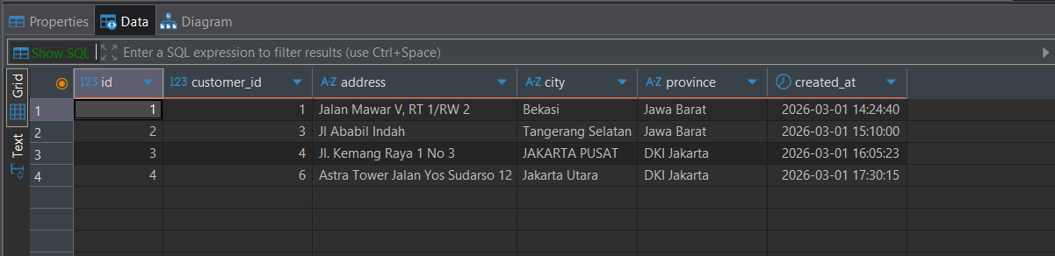

Task 2 / Datamart
- Cleansing data
- v_dim_customers
create or replace view v_dim_customers as
select
id,
name,
case
when dob regexp '^[0-9]{4}/[0-9]{2}/[0-9]{2}$' then str_to_date(dob, '%Y/%m/%d')
when dob like '%/%/%' then str_to_date(dob, '%d/%m/%Y')
else cast(dob as date)
end dob,
created_at
from customers_raw
where dob != '1900-01-01' or dob is null;

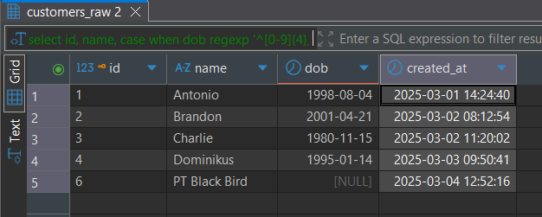

- v_dim_customer_address
create or replace view v_dim_customer_address as
select
id,
customer_id,
address,
case
when city like '%Pusat%' then 'Jakarta Pusat'
else city
end as city,
province,
created_at
from customer_addresses_raw

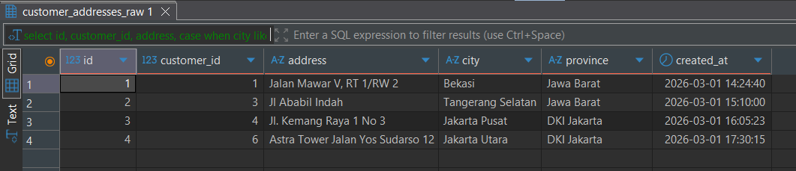
- v_fact_service_logs
create or replace view v_fact_service_logs as
select
service_ticket,
vin,
customer_id,
model,
service_date,
service_type,
created_at
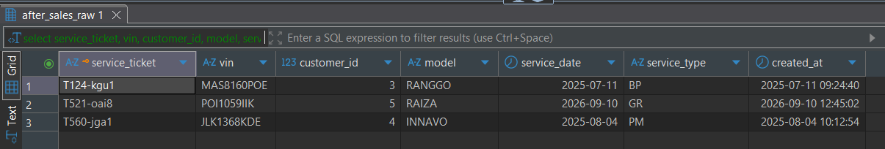
from after_sales_raw;

- v_fact_sales
create or replace view v_fact_sales as
select
vin,
customer_id,
model,
cast(invoice_date as date) as invoice_date,
cast(replace(price, '.', '') as decimal(15,2)) as price_numeric,
created_at
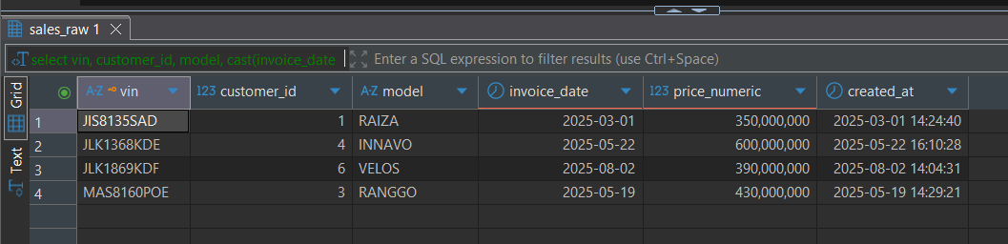
from sales_raw;
- Datamart
- v_dm_sales_performance
create or replace view v_dm_sales_performance as
select
date_format(invoice_date, '%Y-%m') as periode,
case
when price_numeric between 100000000 and 250000000 then 'LOW'
when price_numeric > 250000000 and price_numeric <= 400000000 then 'MEDIUM'
when price_numeric > 400000000 then 'HIGH'
end as class,
model,
sum(price_numeric) as total,
CURRENT_TIMESTAMP() as updated_date
from v_fact_sales
group by 1, 2, 3
order by periode desc, total desc;

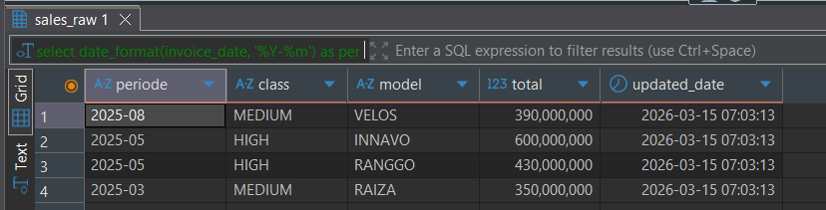
- v_dm_customer_loyalty
create or replace view v_dm_customer_loyalty as
with service_count as (
select
customer_id,
vin,
count(service_ticket) as count_service
from after_sales_raw
group by 1, 2
)
select
date_format(s.invoice_date, '%Y') as periode,
s.vin,
c.name as customer_name,
addr.address,
sc.count_service,
case
when sc.count_service > 10 then 'HIGH'
when sc.count_service between 5 and 10 then 'MED'
else 'LOW'
end as priority,
CURRENT_TIMESTAMP as updated_date
from v_fact_sales s
join v_dim_customers c on s.customer_id = c.id
left join v_dim_customer_address addr on c.id = addr.customer_id
left join service_count sc on s.vin = sc.vin;
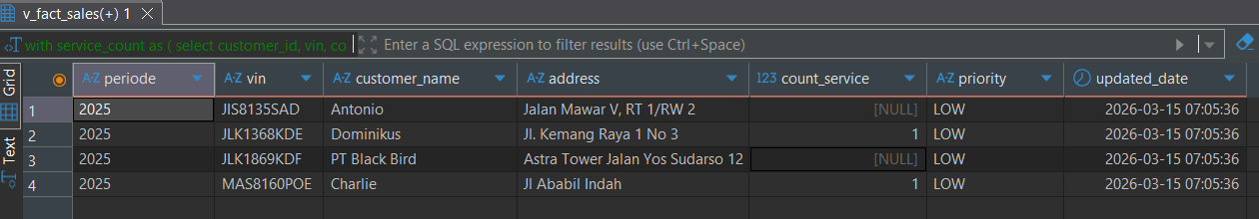

Task 3 / Design
- ERD
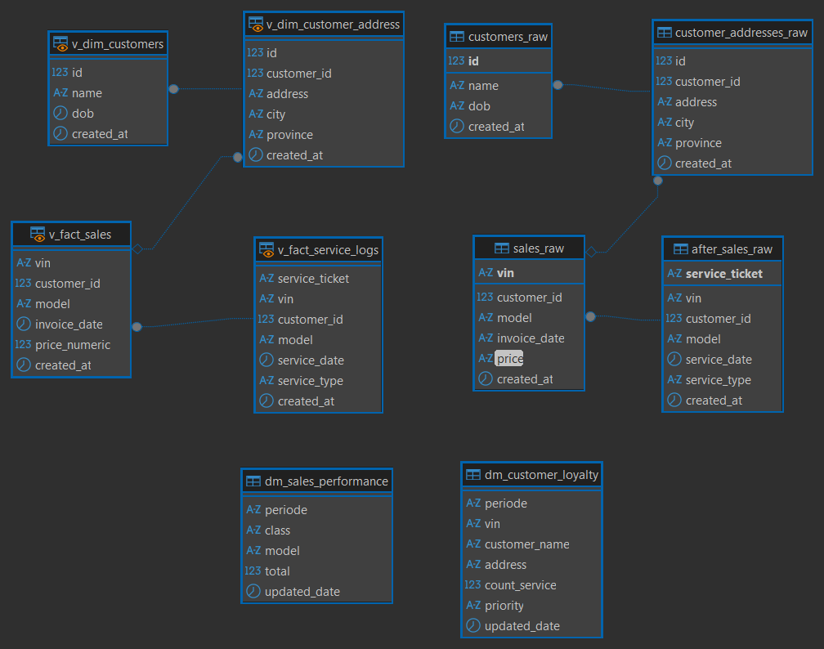
- Architecture
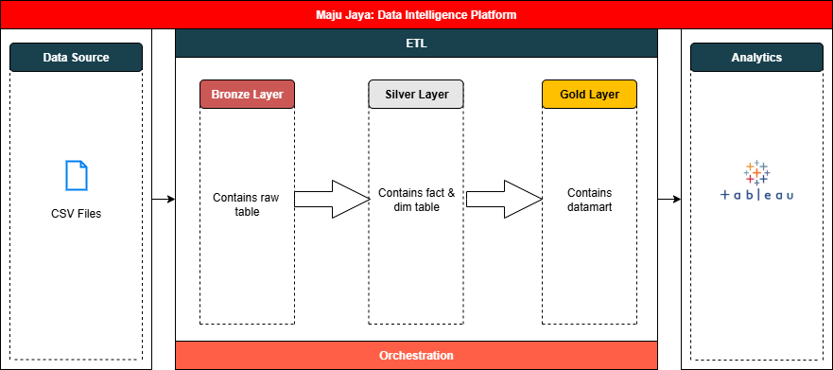
1. Alur Arsitektur Data (High Level)
Desain ini menunjukkan bagaimana data mentah diproses hingga menjadi informasi siap pakai.
- Layer 1: Raw (Bronze)
  - Karakteristik: Data apa adanya dari sumber (As-is).
  - Tabel: customers_raw, sales_raw, after_sales_raw, customer_addresses_raw (hasil Ingest Task 1).
- Layer 2: Trusted (Silver)
  - Karakteristik: Data yang sudah divalidasi, dibersihkan (Cleaning), dan tipe data distandarisasi.
  - Tabel: v_dim_customers, v_dim_customer_address, v_fact_service_logs, v_fact_sales
- Layer 3: Datamart (Gold)
  - Karakteristik: Data agregasi yang siap untuk Reporting/Dashboard.
  - Tabel: dm_sales_performance, dm_customer_loyalty.
Optional / Point plus

